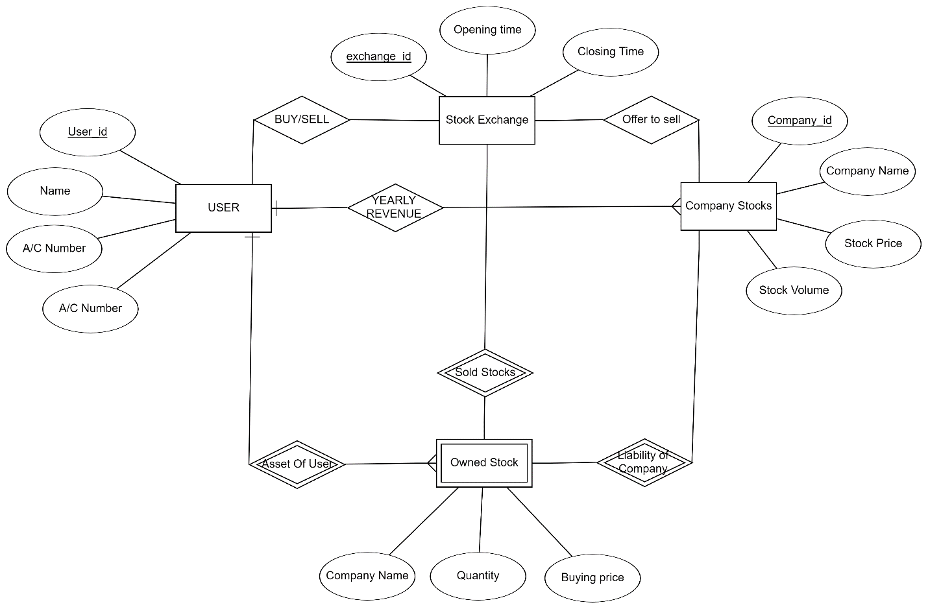

Many

Many

Many

Many

Many

One

One

Many

Many

Many

Many

Many

Fig: Entity Relationship Diagram of a Stock-Exchange Database